**Robins, Elizabeth (1862-1952)**

Born in Louisville, Kentucky in 1862, Elizabeth Robins established herself in the American theatre and then relocated to London in 1888. She epitomizes the grasp that the plays of Henrik Ibsen held on performers in the 1890s. Indeed, she outshone other professionals by laying claim to performing and producing the first English-speaking Hedda Gabler (1891) and the first Hilda Wangel (1893, in *The Master Builder*). She felt that the stage-management system militated against women having a say in their profession, and therefore she welcomed the Independent Theatre Movement. She formed the Joint Management Company with American actress Marion Lea, her stage partner and co-producer for *Hedda Gabler*, and she organized several subscription series to mount not only Ibsen's plays but other artistic theatre. Her feminist play *Votes for Women* (1907) was at the vanguard of pro-suffrage drama.

Performances organized by Robins of *Hedda Gabler* and *The Master Builder* were rivaled in impact only by the initial sensation created by Janet Achurch as Nora Helmer in her London production of *A Doll’s House* in 1889. Robins’s other Ibsen roles included Martha in *The Pillars of Society*, Asta in *Little Eyolf*, Agnes in a production of Act 4 of *Brand*, Ella Reintheim in *John Gabriel Borkman*,Mrs. Linde in *A Doll's House*,and Rebecca West in *Rosmersholm*. Robins also performed roles for J. T. Grein's Independent Theatre, including Jean Creyke in *Alan's Wife*, a play she helped translate and adapt from a Swedish short story. William Archer, Bernard Shaw, and Henry James all credited Robins’s talents.

Disappointment in Ibsen's final play *When We Dead Awaken* drove Robins to critique a cult of the ‘man who stands alone,’ and although she remained indebted to the acting opportunities that Ibsen’s characters had offered her, she effectively retired from the stage after 1902, turning increasingly to writing. Inspired by a suffrage rally that she had witnessed in Trafalgar Square, Robins’s play *Votes for Women* was performed at the Court Theatre in 1907, directed by Harley Granville Barker. The play is structured as the revelation of a ‘woman with a past,’ but with a second-act crowd scene that transforms the public meeting scene reminiscent of Ibsen's *An Enemy of the People* into a vivid suffrage rally. *Votes for Women* was highly influential in demonstrating the potential of the stage as a forum for staging feminist politics, inspiring many other suffrage plays in the years immediately following the Court Theatre production.

In addition to plays and novels, Robins wrote a number of memoirs, as well as suffrage essays and speeches (collected in *Way Stations,* 1913). Her lecture *Ibsen and the Actress* was published by Hogarth Press in 1928 and was followed by *Theatre and Friendship* (containing Henry James correspondence, 1932) and *Both Sides of the Curtain* (1940), as well as the uncompleted sequel to the latter, "Whither and How." These texts clarify Robins’s central role in linking feminism and modernism in drama and theatre over the course of her long career.

**List of Works**

*Alan’s Wife* (1893) (co-authored with Florence Bell; originally published anonymously with a preface by William Archer)

*Votes for Women* (1907)

*Way Stations* (1913)

*Ancilla’s Share: An Indictment of Sex Antagonism* (1924)

*Ibsen and the Actress* (1928)

*Theatre and Friendship: Some Henry James Letters, with a Commentary by Elizabeth Robins* (1932)

*Both Sides of the Curtain* (1940)

*Guide to the Elizabeth Robins Papers*, Fales Library and Special Collections, New York University, <<http://dlib.nyu.edu/findingaids/html/fales/robins/>>.

**References and Further Reading**

Cima, Gay Gibson. (1993) *Performing Women: Female Characters, Male Playwrights, and the Modern Stage.* Ithaca: Cornell University Press.

Farfan, Penny. (2004) *Women, Modernism, and Performance*. Cambridge: Cambridge University Press.

Gates, Joanne E. (1994) *Elizabeth Robins, 1862-1952: Actress, Novelist, Feminist*. Tuscaloosa: University of Alabama Press.

John, Angela V. (1995) *Elizabeth Robins: Staging a Life*, London: Routledge.

Heath, M. T. (1986) "A Crisis in the Life of the Actress: Ibsen in England." PhD diss. University of Massachusetts, Amherst.

Marcus, Jane. (1988) *Art and Anger: Reading like a Woman.* Columbus: Ohio State University Press.

Stowell, Sheila. (1992) *A Stage of Their Own: Feminist Playwrights of the Suffrage Era.* Ann Arbor: University of Michigan Press.

**Joanne E. Gates, Jacksonville State University**

**Recommended Illustrations** [please use all three images if possible]

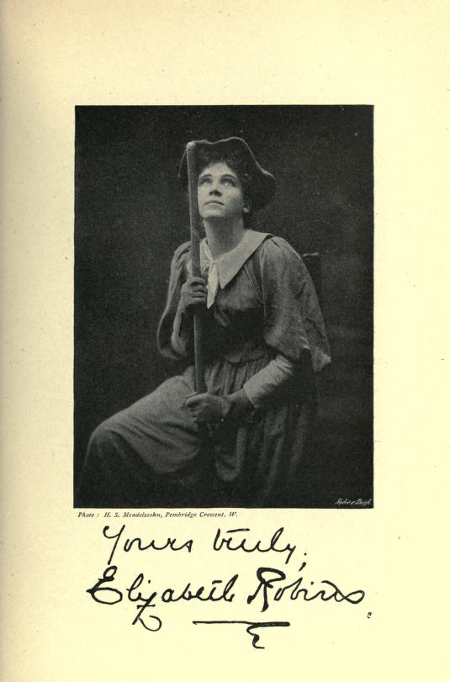

**Studio portrait of Elizabeth Robins as Hilda in Ibsen's *The Master Builder*.**

[Available at <https://archive.org/stream/cassellsuniversa00londiala#page/188/mode/2up>

Source: *Cassell's Universal Portrait Gallery* (1885), p. 199.]

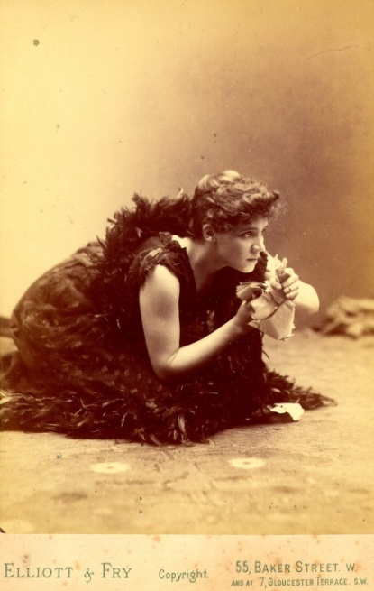

**Studio portrait of Elizabeth Robins as Hedda Gabler.**

[Elizabeth Robins Papers, Fales Library, New York University, available at: http://www.nyu.edu/library/bobst/research/fales/exhibits/wilde/images/erobins.jpg

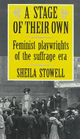

**The suffrage rally scene in *Votes for Women*, Court Theatre, 1907**

[The image was published in the London journal *The Sketch* (15 May 1907) and is reproduced on the cover of Sheila Stowell’s book *A Stage of Their Own: Feminist Playwrights of the Suffrage Era* (Ann Arbor: University of Michigan Press, 1992): see http://books.google.ca/books?id=WN4R1jaTN6wC&printsec=frontcover&source=gbs_ge_summary_r&cad=0#v=onepage&q&f=false]